**THE TRAGEDY OF FLIGHT: A COMPREHENSIVE CRASH ANALYSIS**

**INTRODUCTION:**

**OVERVIEW:**

**An airplane crash analysis is a detailed investigation into the causes of an aviation accident. The goal of an airplane crash analysis is to identify any factors that contributed to the accident, with the** **ultimate goal of improving safety and preventing future accidents. The process of conducting an airplane crash analysis typically involves the collection and analysis of a wide range of data, including information about the aircraft and its systems, the operators, and any other relevant factors. This data is typically collected from Kaggle. Once the data has been collected, it is analyses through a tableau, to identify any potential causes of the accident. The results of an airplane crash analysis are typically published in a report, which may include recommendations for improving safety and preventing similar accidents in the future. These recommendations may be implemented by the relevant authorities or industry organizations.**

**PURPOSE:**

**Flight crash analysis is performed to determine the cause of errors once an accident has happened. In the modern aviation industry, it is also used to** **analyze a database of** **the past accidents** **in order to prevent an** **accident** **in order to prevent an accident from happening. An airplane crash analysis is a detailed investigation into the causes of an aviation accident. The goal of an airplane crash analysis is to identify any factors that contributed to the accident, with the** **ultimate goal of improving safety and preventing future accidents. Analysis authorities also provide recommendations for safe operations. Investigation and analysis of safety occurrence is an essential ingredient of the overall risk management process in aviation. Effective safety management systems largely depend on the quality of the investigation of reported accidents, incidents and safety issues.** **The latest edition of the Statistical Analysis of Commercial Aviation Accidentspublished annually,provides a rich source of information in this area. Focusing on Western built jets over 40 seats, it firstly highlights that with around 22 million flight departures in 2021, the number of flights remained 40% lower than in 2019 before the pandemic, when almost 36 million flights were registered.**

**The analysis also points out that 2021 was a year that reported one of the lowest number of accidents. Five of these were registered, one less than in 2020. “This is a slight improvement when compared to the previous years, which indicates the industry's resilience to maintain a level of safety despite the challenges of the ongoing Covid-19 crisis. However, with the number of flights still lower than pre-pandemic levels, it is not possible to say if it shows a sustained improvement of the overall safety performance”, the document reads.**

**DATASET:**

* **Empathy map.**
* **Ideation & Brainstorming map.**
* **Comparing of aboard vs fatalities vs ground.**
* **The number of accidents based on the years.**
* **Accidents happened in the years of maximum accidents.**
* **Highest number of accidents which** **are happened by the operators.**
* **Location with the maximum accident history.**
* **Flight accident history.**
* **Number of accidents based on the regions.**

**PROBLEM DEFINITION & DESIGN THINKING:**

**EMPATHY MAPPING:**

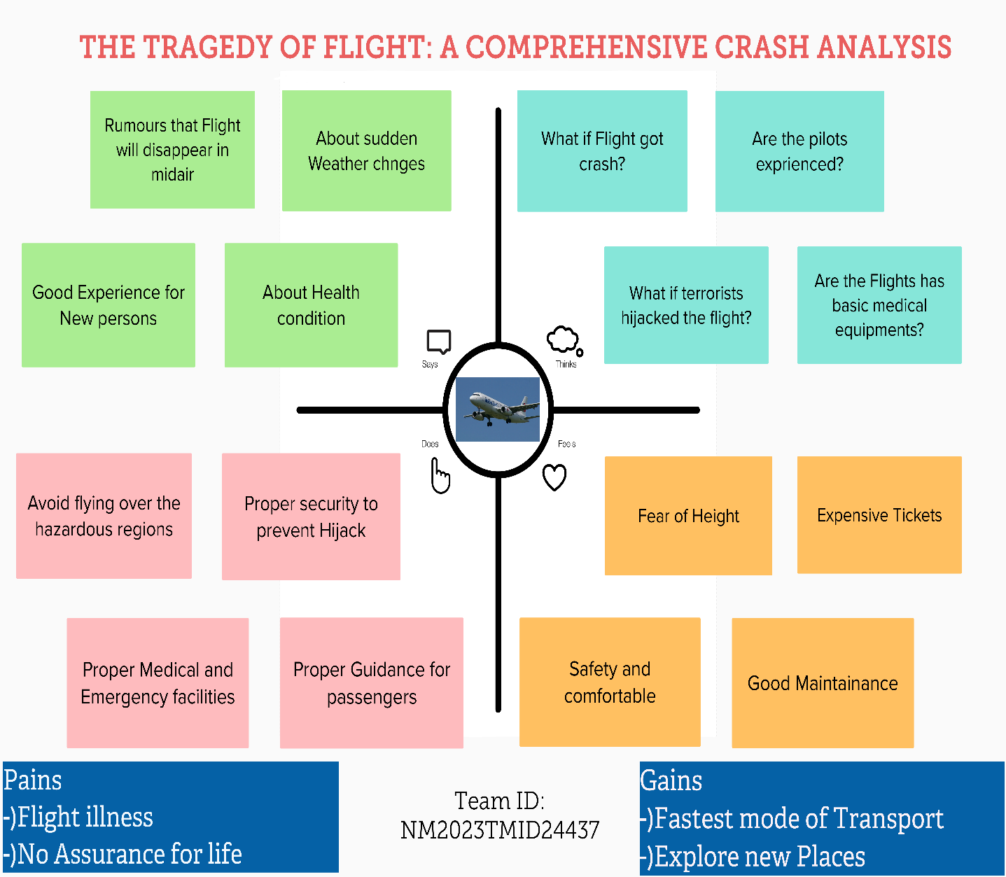

**IDEATION & BRINSTORMING MAP:**

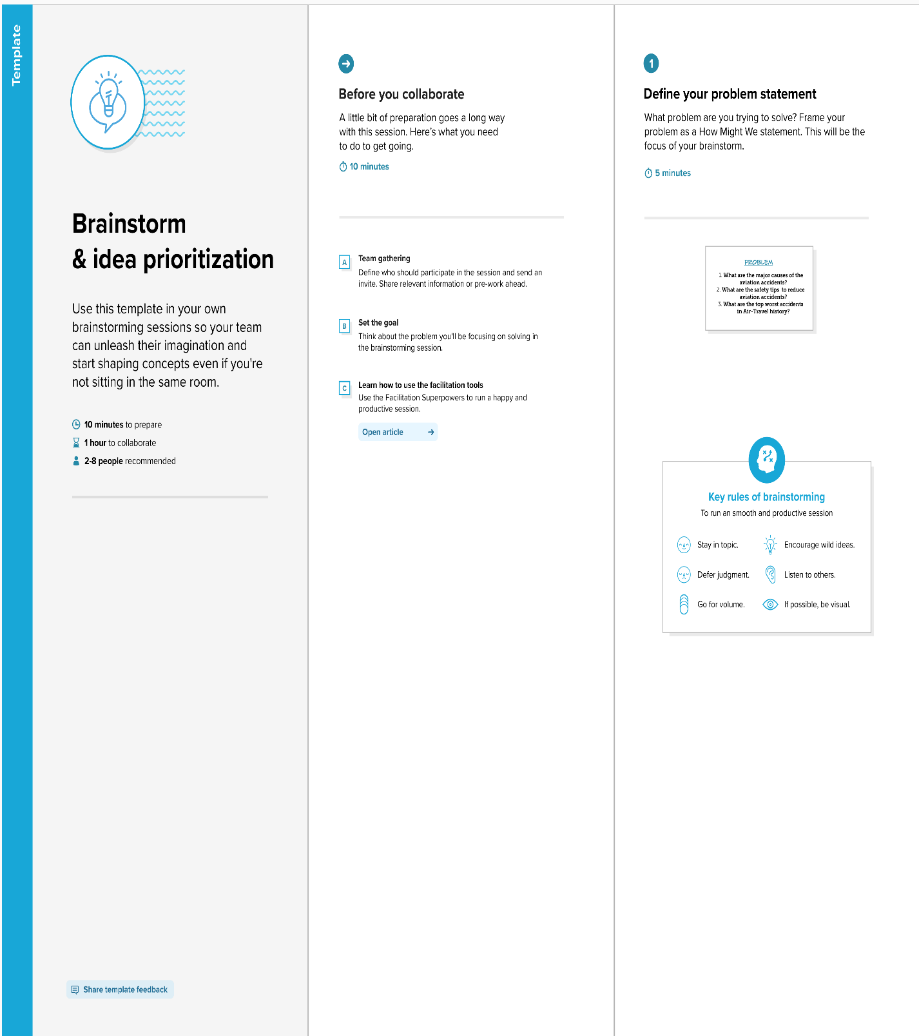

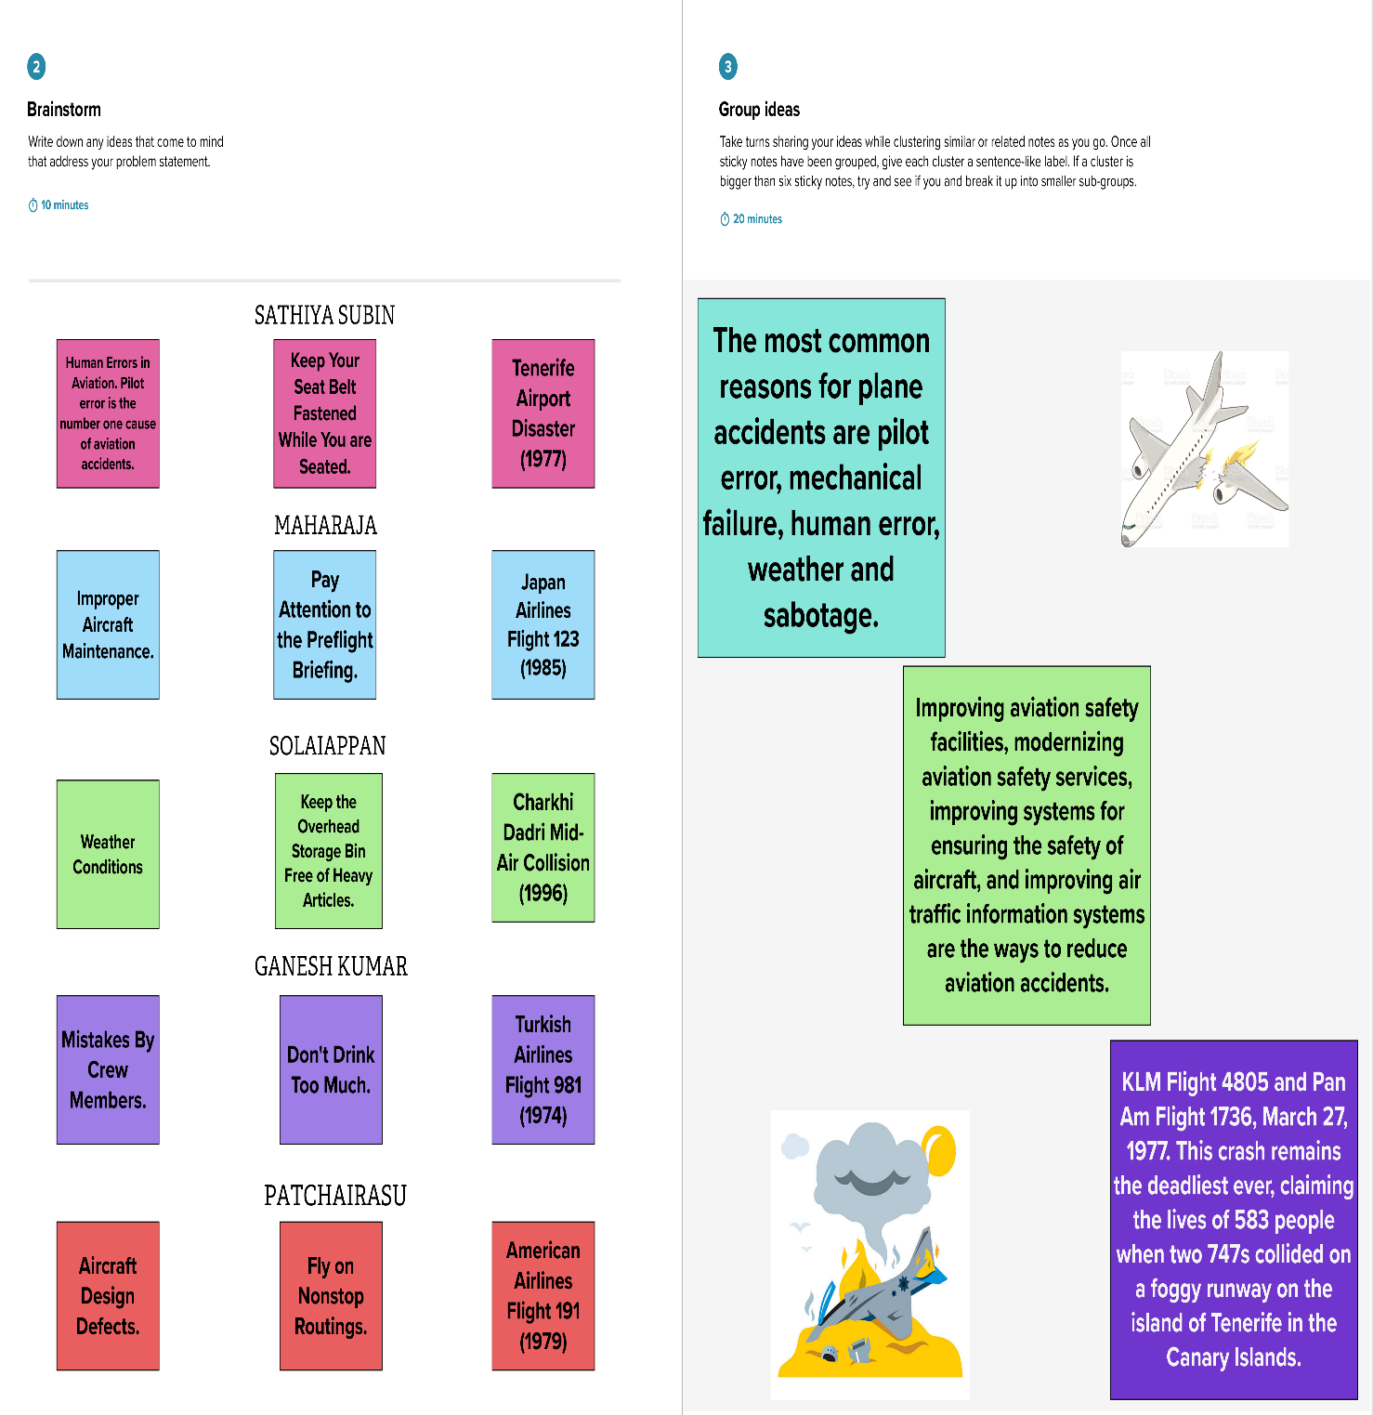

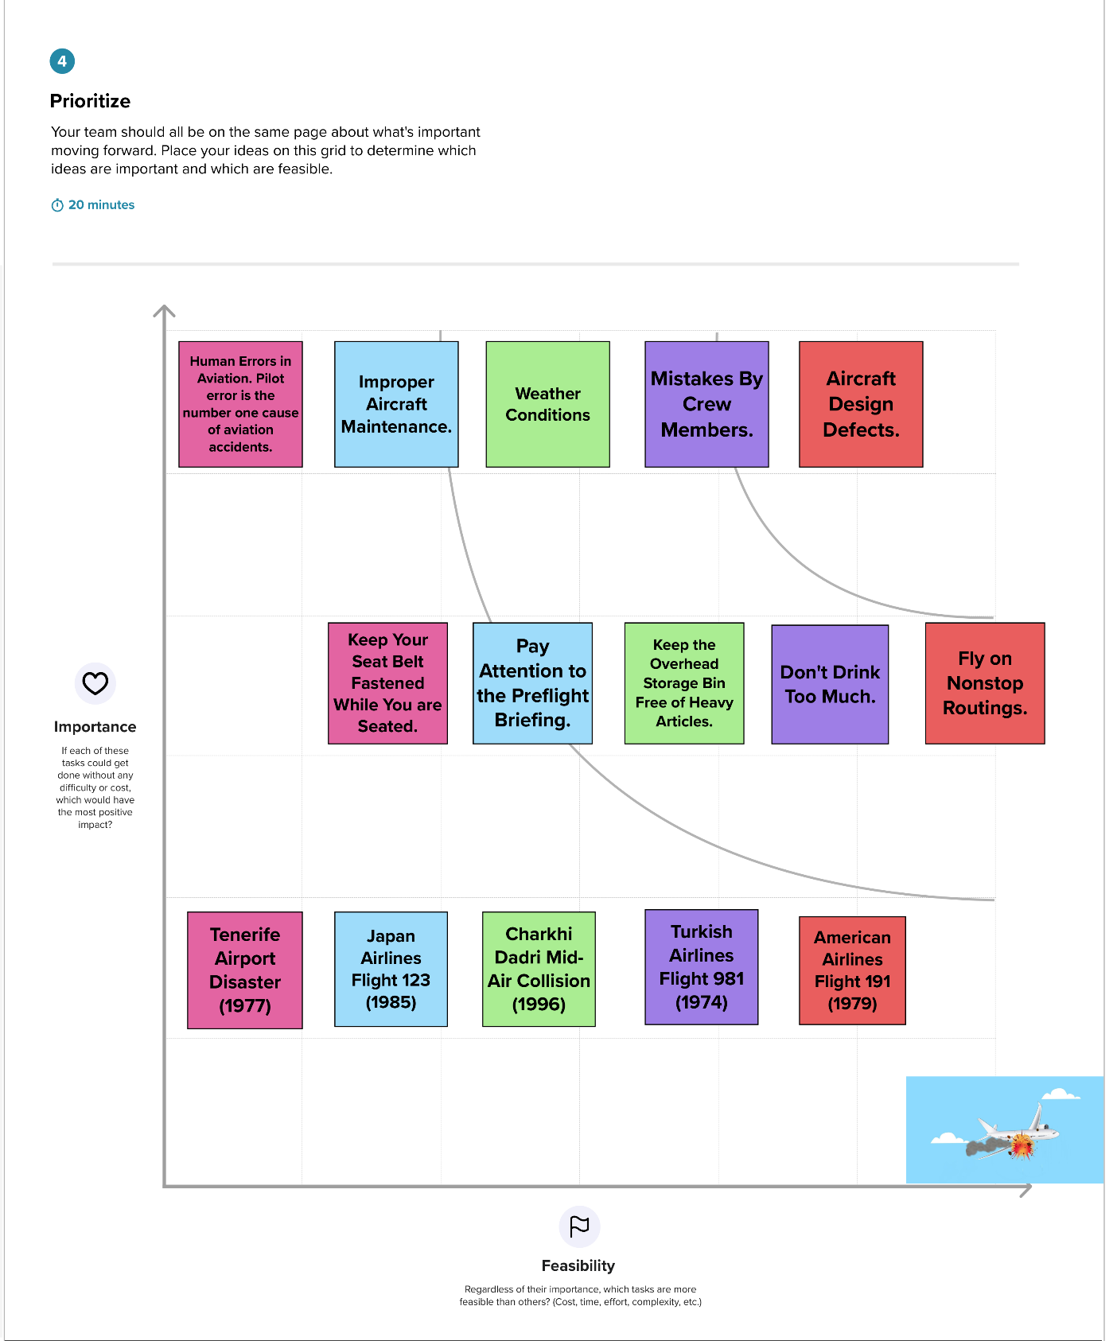

**RESULT:**

**ACTIVITY 1:**

**COMPARING ABOARD VS FATALITIES VS GROUND**

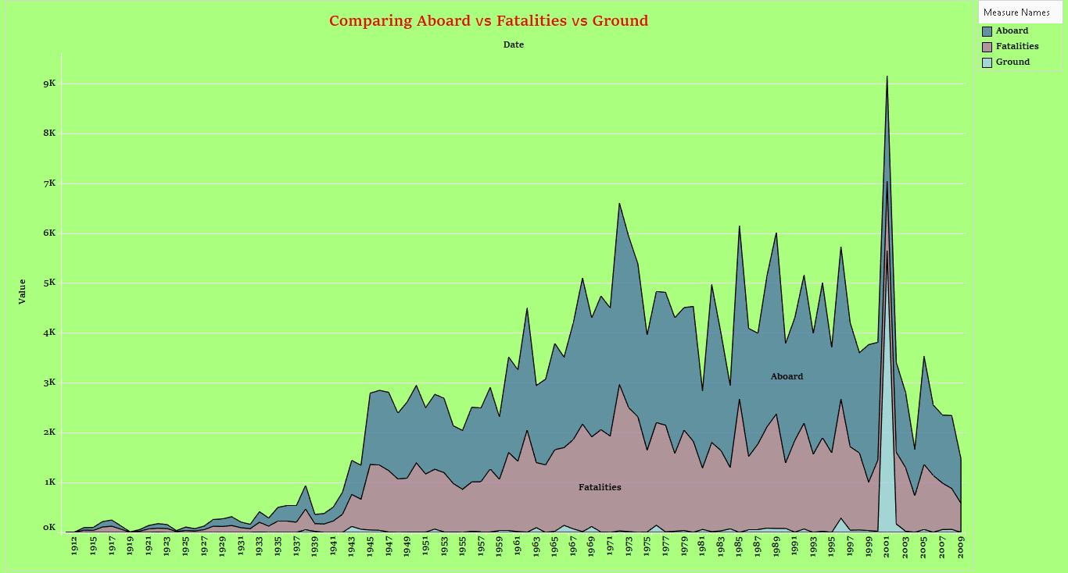

**ACTIVITY 2:**

**MAX ACCIDENTS BASED ON YEARS**

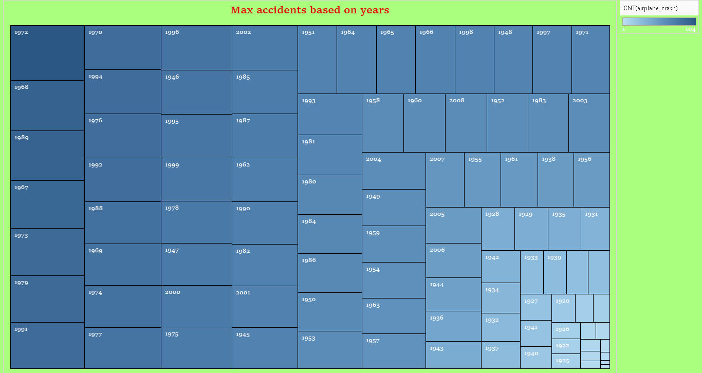

**ACTIVITY 3:**

**ACCIDENTS HAPPENED IN 1972 (MAX ACCIDENTS) BASED ON YEARS**

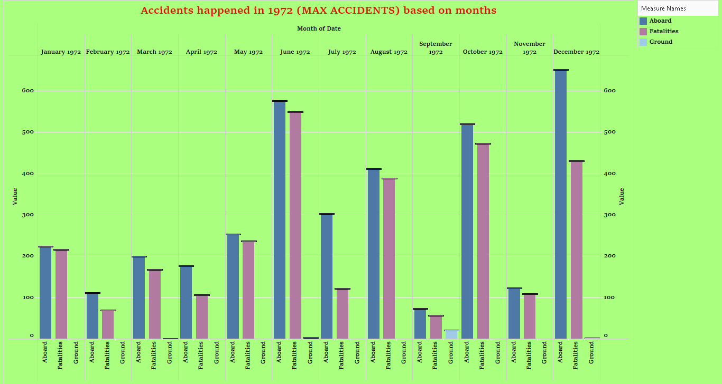

**ACTIVITY 4:**

**HIGHEST NUMBER OF ACCIDENT HAPPENED BY OPERATORS**

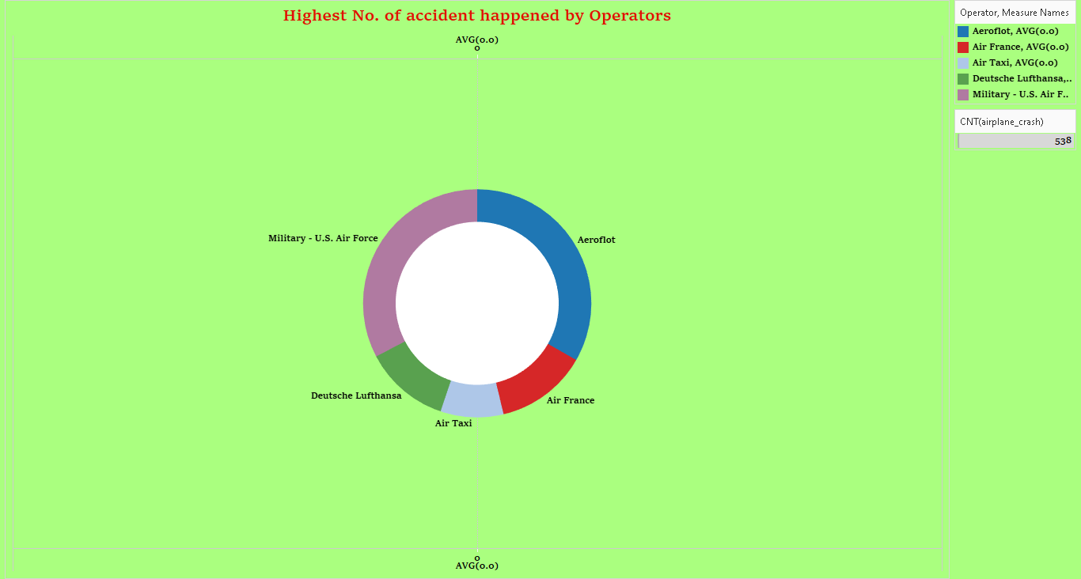

**ACTIVITY 5:**

**TOP 10 LOCATIONS WHICH HAD MORE ACCIDENTS**

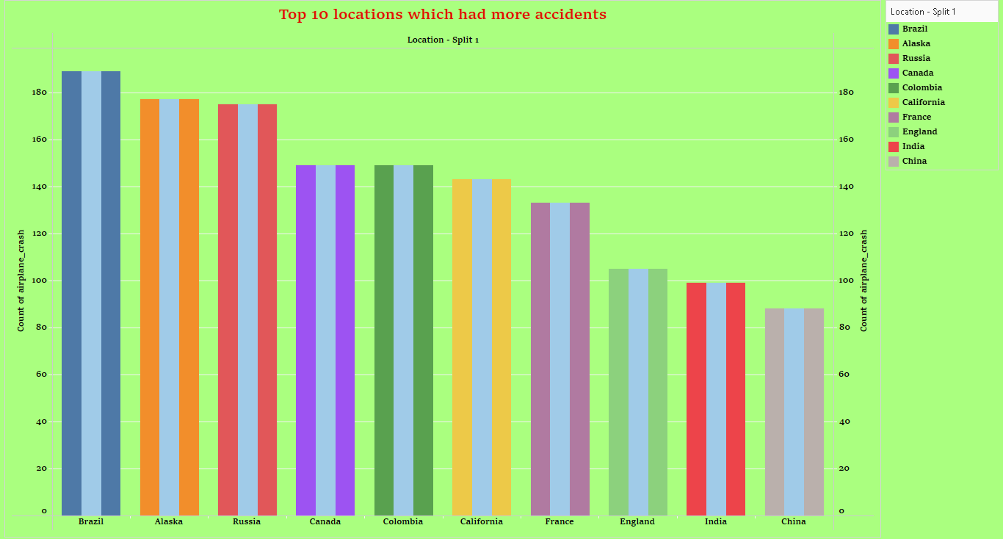

**ACTIVITY 6:**

**TOP 3 FLIGHTS WHICH HAVE MAX ACCIDENT HISTORY**

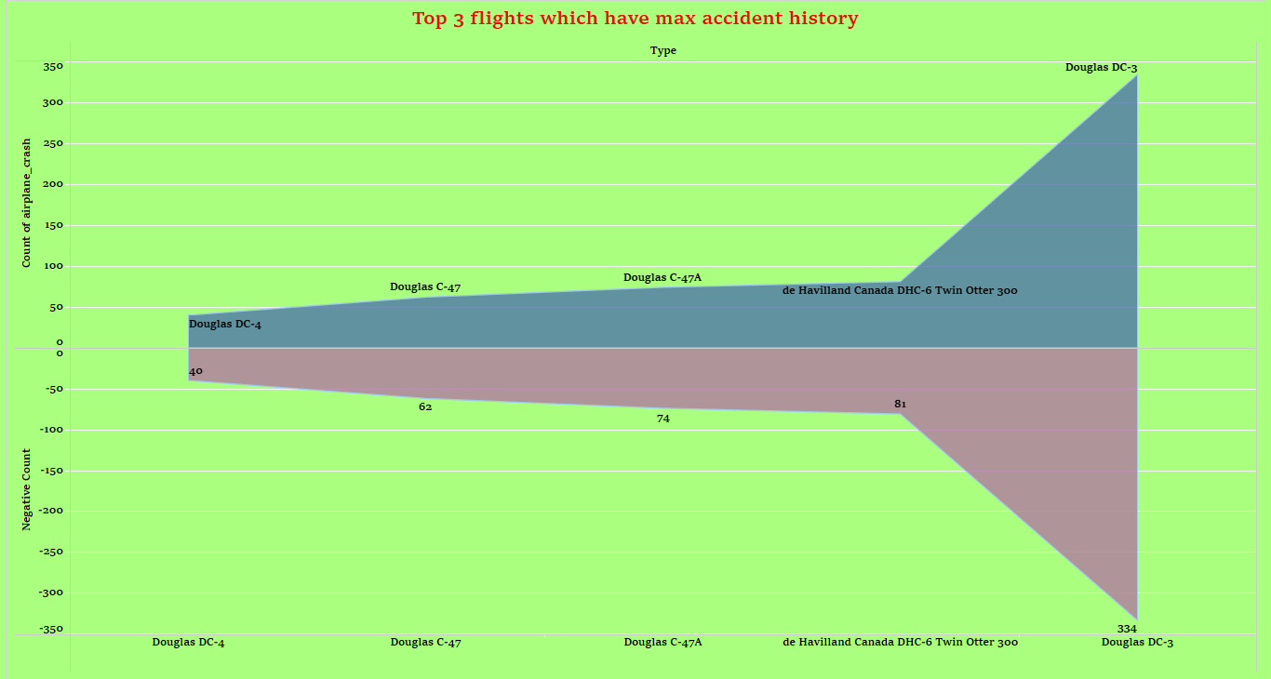

**ACTIVITY 7:**

**ACCIDENTS BASED ON REGIONS**

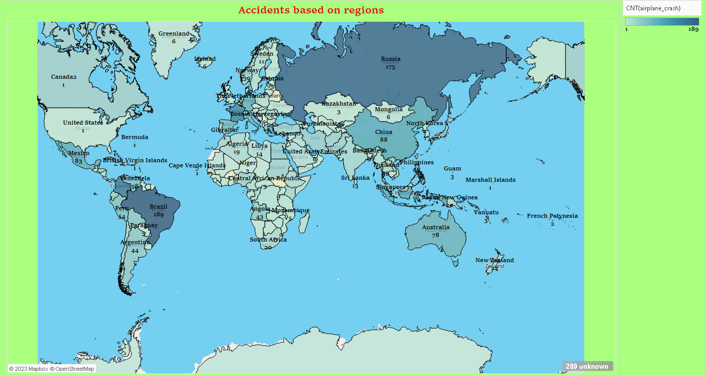

**ADVANTAGES:**

* **A key to** **prevent future accidents.**
* **Understanding the events that led up** **to an accident can help to determine the cause. Each accident should be treated as a learning opportunity.**
* **Once the cause of the accident is determined, corrective actions can be taken to prevent the same or similar losses from occurring again.**
* **Discovering patterns in accidents may help determine if procedures need to be altered to keep people and property safe.**
* **Sharing information and discoveries helps to prevent future accidents and can reduce risks for others.**

**DISADVANTAGES:**

* **The airplane crash analysis study is taken only when a flight met with an accident.**
* **The analysis needs more time to** **investigate about the flight crash.**
* **The cost of operation is high.**
* **The airplane crash will affect the environment and pollute the environment.**
* **Lack of confidence about airplane journey between the peoples.**

**APPLICATIONS:**

**1. Topmost causes for accidents:**

* **1. Loss of control in-flight (LOC-I)**
* **2. Controlled flight into terrain (CFIT)**
* **3. System component failure – power plant (SCF-PP)**
* **4. Fuel-related problems**
* **5. Unknown or undetermined**

**2.Reduce aviation accidents:**

* **Fly on nonstop routings.**
* **Keep your seat belt fastened while you are seated.**
* **Don't bring any hazardous material.**
* **Proper training for pilots.**
* **Avoid flying between clouds.**

**3.Benefits of aviation analysis:**

**Aviation accident analysis is performed to determine the cause of errors once an accident has happened. In the modern aviation industry, it is also used to analyze a database of past accidents** **in order to prevent an accident from happening. Many models have been used not only for accident investigation but also for educational purposes.**

**4.visual Flight rules:**

**In aviation, visual flight rules (VFR) are a set of regulations under which a pilot operates an aircraft in-weather conditions generally clear enough to allow the pilot to see where the aircraft is going. Specifically, the weather must be better than basic VFR weather minima, i.e., in visual meteorological conditions (VMC), as specified in the rules of the relevant aviation authority. The pilot must be able to operate the aircraft with visual reference to the ground,** **and by visually avoiding obstructions and other aircraft.**

**CONCLUSION:**

**The four phases of accident investigations are: preparation (which begins now), data collection, analysis and reporting. Aircraft accident investigation is a process that works best when it is used in its entirety. It cannot be emphasized enough: Conclusion must be supported by all the information and evidence that is gathered utilizing the technique associated with the three** **W ’s of aircraft accident investigation: What happened? Why did it happen? What can be done to prevent it?**

**We visualized the data with the help of tableau and the visualizations are,**

* **Comparing aboard vs fatalities vs ground.**
* **Max accidents based on the years.**
* **Accidents happened in 1972 (MAX ACCIDENTS) based on the months.**
* **Highest number of accidents happened by operators.**
* **Top 10 locations which had more accidents.**
* **Top 3 flights which have max accident history.**
* **Accidents based on regions.**

**We attached our dashboard and story below,**

**Dashboard 1:**

[**https://public.tableau.com/views/Dashboard1_16819158827550/Dashboard1?:language=en-US&:display_count=n&:origin=viz_share_link**](https://public.tableau.com/views/Dashboard1_16819158827550/Dashboard1?:language=en-US&:display_count=n&:origin=viz_share_link)

**Dashboard 2:**

[**https://public.tableau.com/views/Dashboard2_16819159353050/Dashboard2?:language=en-US&:display_count=n&:origin=viz_share_link**](https://public.tableau.com/views/Dashboard2_16819159353050/Dashboard2?:language=en-US&:display_count=n&:origin=viz_share_link)

**Story:**

[**https://public.tableau.com/shared/M77JQJW8K?:display_count=n&:origin=viz_share_link**](https://public.tableau.com/shared/M77JQJW8K?:display_count=n&:origin=viz_share_link)

**FUTURE SCOPE:**

**The future scope of aviation accident analysis is a multidisciplinary field that involves various approaches such as forensic or historic approach and predictive approach. The forensic approach is based on accident and incident investigation and analysis. It uses proven investigative techniques to discover all facts pertinent to a past aviation incident or accident, and thus identify opportunities for improvements meant to avoid similar accidents in the future. The predictive approach is based on the use of data analytics and machine learning techniques to predict future aviation accidents.**

**The latest edition of the Statistical Analysis of Commercial AviationAccidentspublished annually,provides a rich source of information in this area. Focusing on Western built jets over 40 seats, it firstly highlights that with around 22 million flight departures in 2021, the number of flights remained 40% lower than in 2019 before the pandemic, when almost 36 million flights were registered.**

**The analysis also points out that 2021 was a year that reported one of the lowest number of accidents. Five of these were registered, one less than in 2020. “This is a slight improvement when compared to the previous years, which indicates the industry's resilience to maintain a level of safety despite the challenges of the ongoing Covid-19 crisis. However, with the number of flights still lower than pre-pandemic levels, it is not possible to say if it shows a sustained improvement of the overall safety performance”, the document reads.**

**APPENDIX:**

**SOURCE CODE:**

**The link below shows our project**

<file:///C:/Users/sathi/Downloads/Day/Day/index.html>